ARYAMAN MISHRA

19BCE1027

a)Write an 8086 ALP to perform Ascending & Descending order of sorting of given numbers in an array.

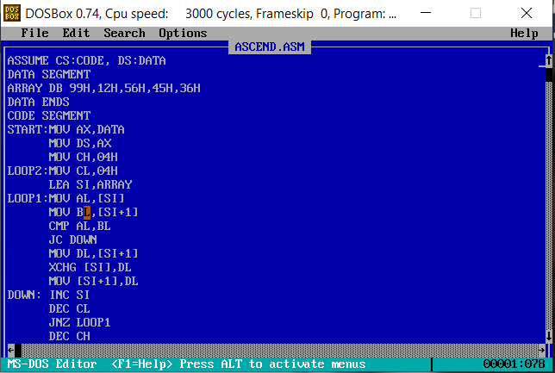

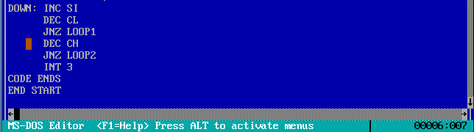

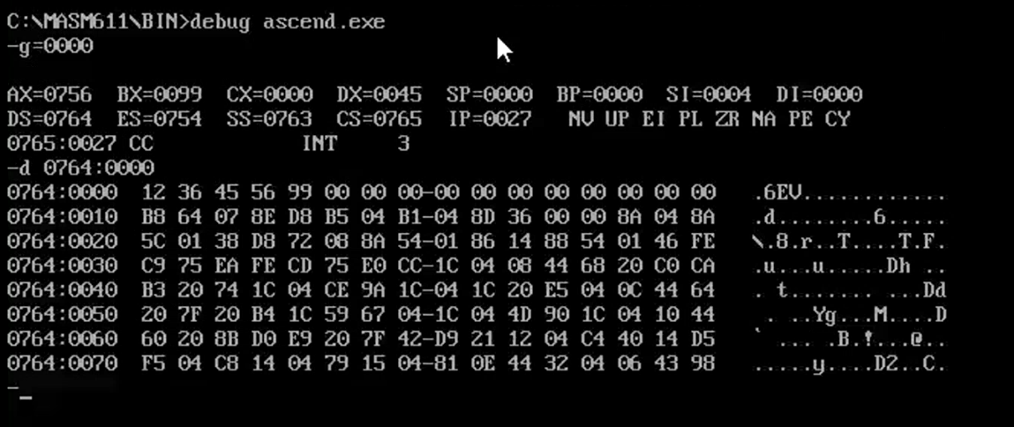

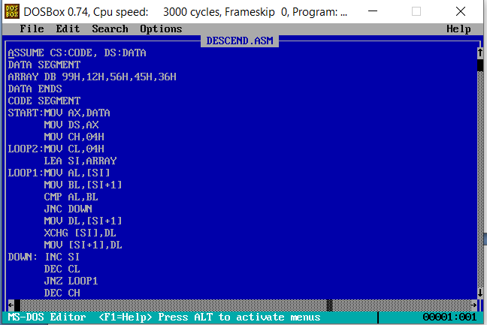

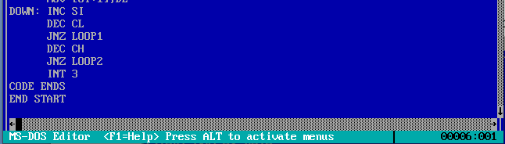

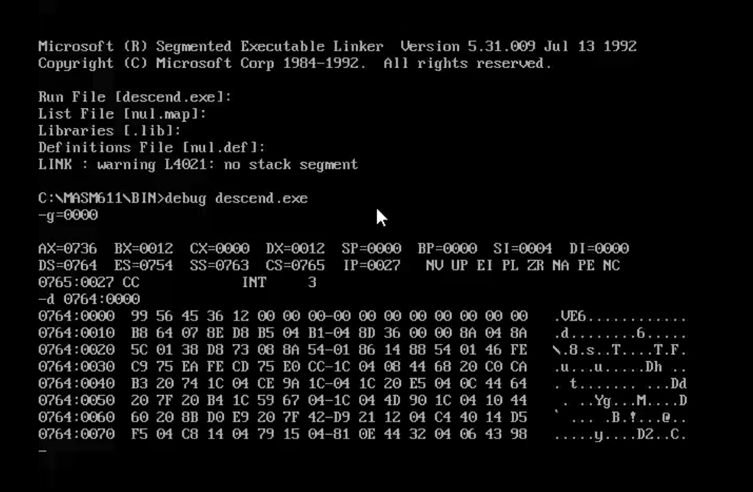

b)Write an 8086 ALP to find the smallest and largest number from an array of 05, while finding the array size and data inputs are fed from memory location 5000H to 50004 and the result has to be stored in the location 6000H

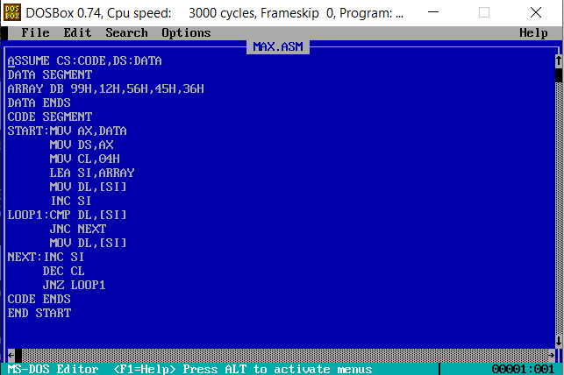

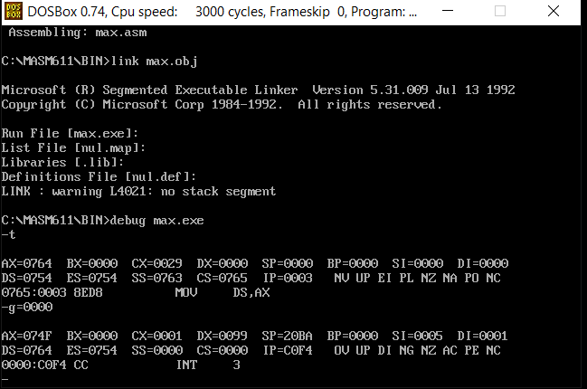

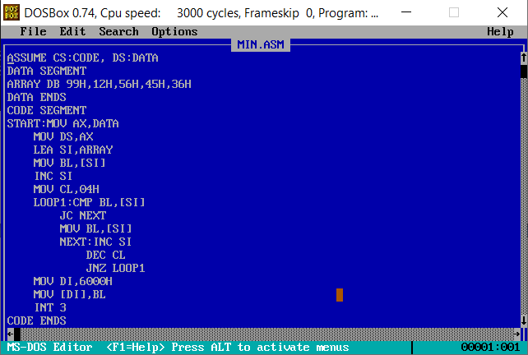

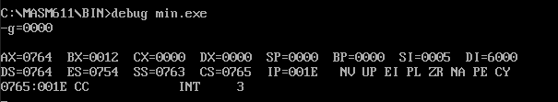

c) Write an 8086 ALP to find the number is present in the array or not, if it is present then display the current memory location of the searched number.

